City loses footy champ Geoff Tunbridge

By Matthew Dixon
March 24, 2015, 12:49 a.m.
See your ad here
THE Ballarat and football community is mourning the loss of Geoff Tunbridge, who died on Monday morning.
The Melbourne Football Club great was a three time VFL premiership player who played 117 games for the club.
Tunbridge was also a teacher at Ballarat Grammar from 1950 to 1990, where he spent time as the football coach. The main oval at the school was named in his honour in 1996.
Melbourne FC spokesman Ryan Larkin said Tunbridge joined the Demons in 1957 as a 25-year-old.
“His dash and long goal kicking ability was a highlight in his six seasons in the red and blue and he finished up playing in four grand finals for three premierships,” Mr Larkin said.
“Despite his slight frame he was incredibly durable, missing just two games to finish on 117 games with 128 goals to his name.
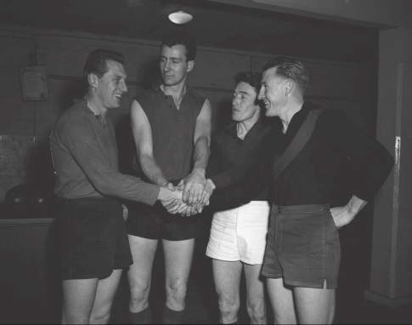
MATES: Geoff Tunbridge, second from right, with Melbourne teammates Don Williams, Bob Johnson, and John Beckwith in 1958.
“Described by those who watched him play as a ‘champion half forward’ and a ‘devastating player’, ‘Tunna’ was a favourite amongst his teammates for his dedication and commitment to the club.”
Tunbridge also played 57 games for the Ballarat Football Netball Club between 1955 and 1964 and was inducted as a life member for the BFNL in 1987.
See your ad here
He was father to five children, two step-children and had 14 grandchildren.

